Basic Queries
Problem Statement: Which ordering channel do Starbucks customers use the most and how does channel preference vary across the four available options?
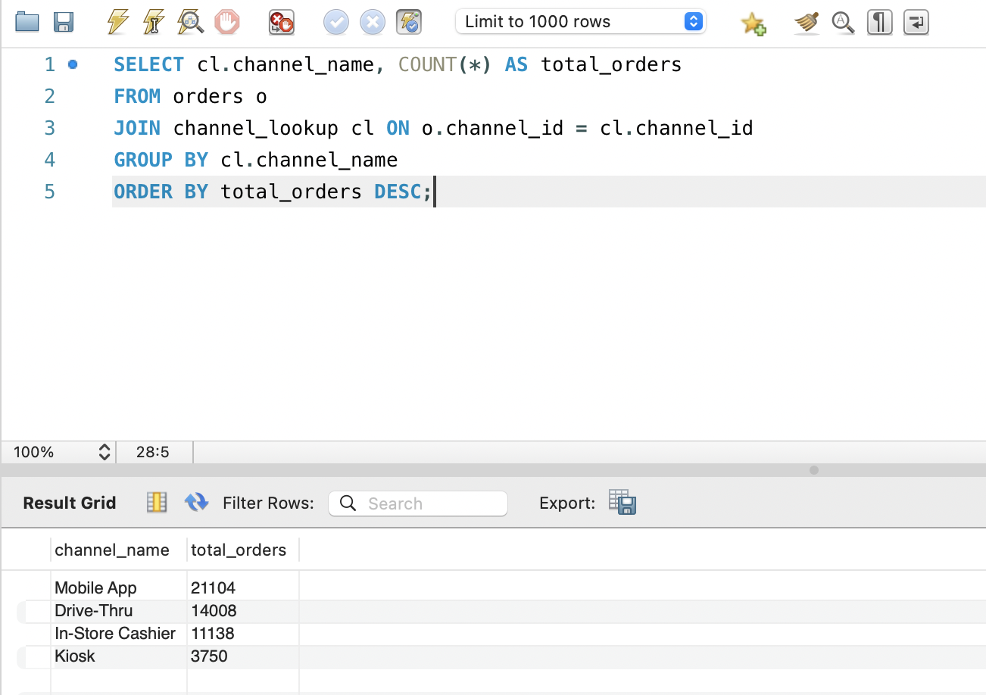
Key finding: Mobile App dominates with 21,104 orders (42%) confirming Starbucks' digital strategy is working, while Kiosk remains significantly underutilized at just 3,750 orders.

To further explain :
1. I wrote a basic SELECT query joining orders and channel_lookup to count how many orders were placed through each channel this confirms the dataset is loaded correctly and the FK relationship between the two tables works.
2. I used GROUP BY on channel_name to aggregate order counts per channel, and ORDER BY DESC to rank channels from most to least used.
3. Mobile App is the most popular channel with 21,104 orders (42% of all orders) showing Starbucks customers strongly prefer digital ordering over in-person methods.
4. Drive-Thru comes second with 14,008 orders, while In-Store Cashier has 11,138 together these three channels account for over 92% of all orders.
5. Kiosk is the least used channel with only 3,750 orders suggesting customers either don't find kiosks convenient or are unaware of them.

Problem Statement: What is the gender distribution of Starbucks customers and does the brand appeal equally across all gender groups?
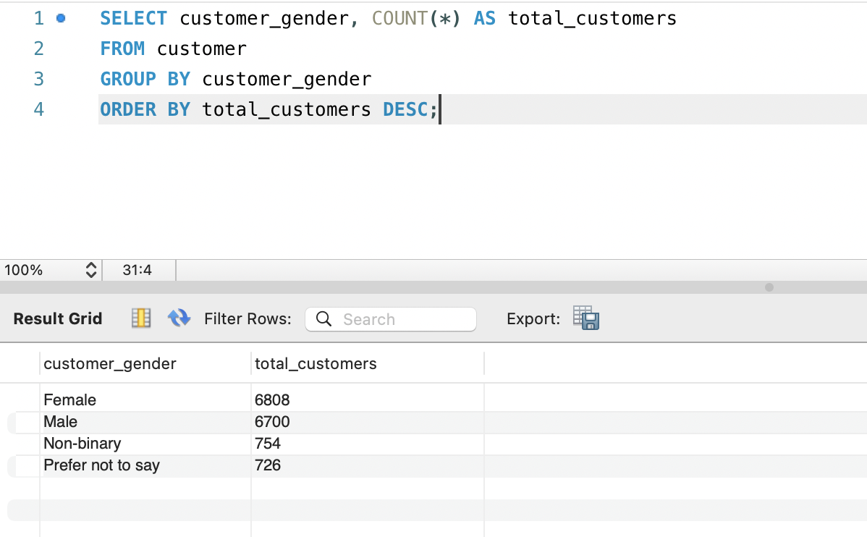
Key finding: Starbucks' customer base is nearly gender-balanced, Female (6,808) and Male (6,700) are almost equal, with 10% identifying as Non-binary or preferring not to disclose.

To further explain :
1. I wrote a simple SELECT query on the customer table to count how many unique customers belong to each gender category, this confirms customer demographic data loaded correctly with no nulls or missing groups.
2. I used GROUP BY on customer_gender to aggregate customer counts per gender, and ORDER BY DESC to rank from largest to smallest group.
3. Female customers are the largest group at 6,808 followed closely by Male at 6,700 and the difference is only 108 customers, meaning the customer base is almost perfectly balanced between the two.
4. Non-binary customers account for 754 and "Prefer not to say" for 726 together about 10% of the total customer base, showing Starbucks' dataset captures gender inclusively beyond binary categories.
5. The near-equal split between Female and Male suggests Starbucks has broad demographic appeal and is not skewed toward any single gender group.

Avance Query
Problem Statement: Identify which Starbucks ordering channels have above-average wait times and below-average satisfaction scores, to pinpoint where operational improvements are most needed.
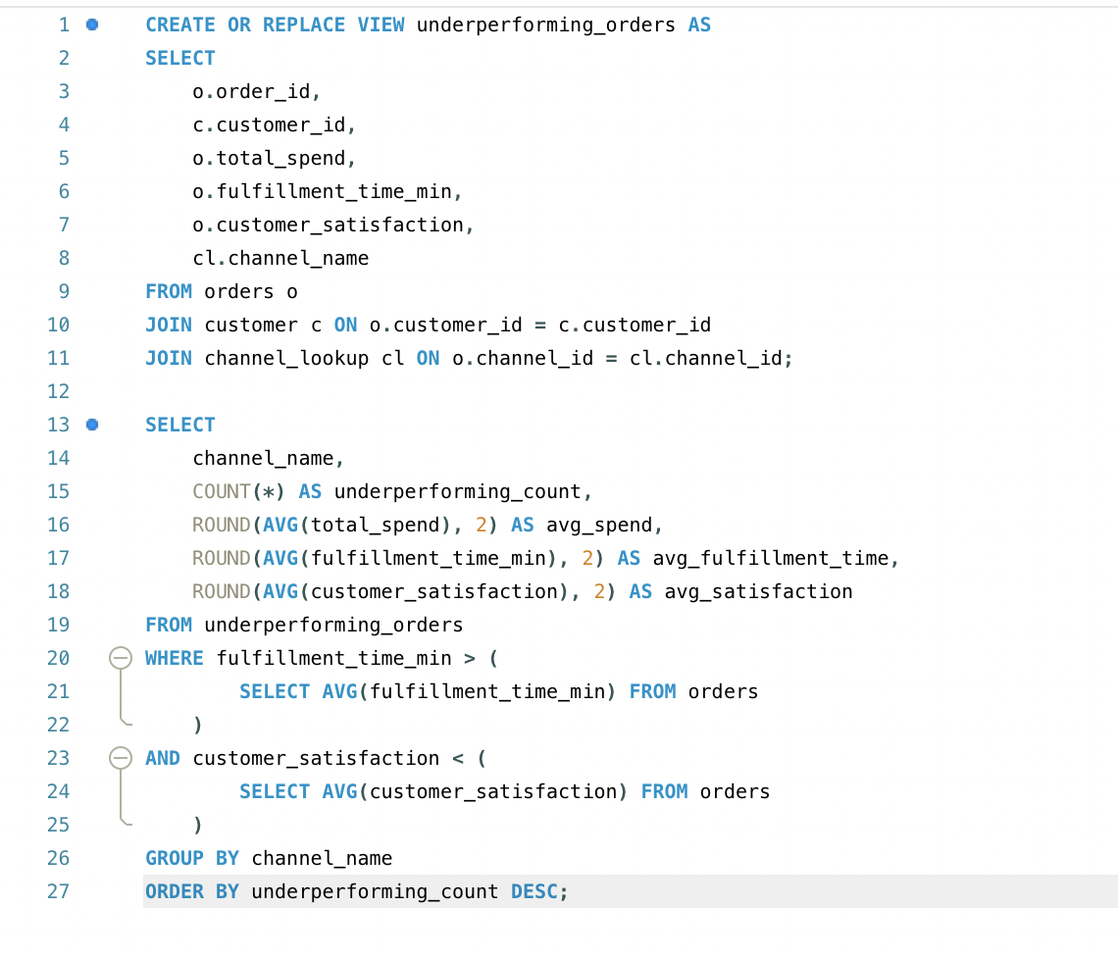
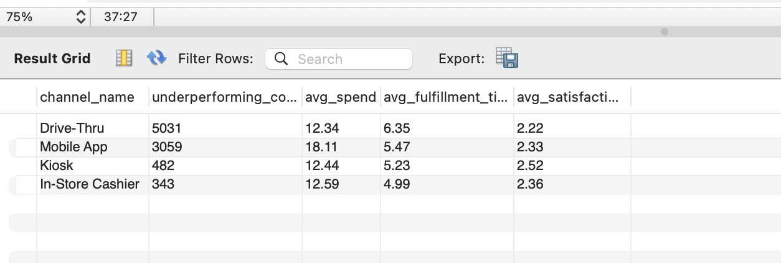
Key Finding : Drive-Thru leads with 5,031 underperforming orders and the lowest satisfaction (2.22/5) making it Starbucks' biggest operational risk.

To further explain :
- I created a VIEW by joining 3 tables orders, customer, and channel_lookup so the combined data can be reused across multiple queries without rewriting the joins every time.
- Instead of manually setting a fixed number as the cutoff, I used two subqueries that automatically calculate the current average fulfillment time and satisfaction score from the data itself so the query stays accurate even if the dataset changes.
Instead of using “WHERE fulfillment_time_min > 5.5 -- someone manually typed this number”
I have used “WHERE fulfillment_time_min > (SELECT AVG(fulfillment_time_min) FROM orders)”.
This means the threshold calculates itself from the data automatically. If tomorrow the dataset grows from 50,000 to 500,000 rows, the query still works correctly without anyone changing any numbers manually.
- Drive-Thru had the most underperforming orders at 5,031 nearly double Mobile App with the lowest satisfaction (2.22/5) and longest wait time (6.35 min), indicating clear operational bottlenecks in this channel.
- Mobile App underperformers spent the most on average ($18.11) yet still reported poor satisfaction (2.33/5) suggesting high-spending customers have higher expectations and are more sensitive to delays.
- In-Store Cashier had the fewest underperforming orders (343) and fastest service (4.99 min) making it the most reliable channel despite being the most traditional.

